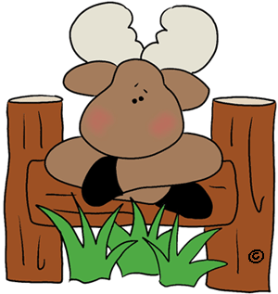 Merry Moose Childcare Infant Center Checklist

How exciting! The day has finally arrived for your little one to attend care. We are so excited and want your fist days to be seamless. Below is a checklist of items you will want to provide for your little one. If you have any questions, ever, reach out to our knowledgeable staff.
I look forward to watching your little one grow and develop in our programs at Merry Moose Childcare and Preschool LLC.
Mande Hatten
Owner and Director
Item(s) | Packed?
2 Pacifiers
2 sets clothing
Swaddle
Sleep Sack
Formula
Breastmilk
Diapers
Diaper Ointment
Required Forms
Questions?

